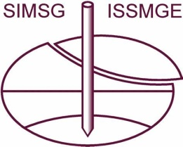 | TC219 SYSTEM PERFORMANCE  International Society for Soil Mechanics and Geotechnical Engineering | 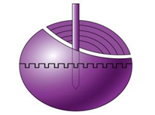  CISMGE-CCES

Gang ZHENG | 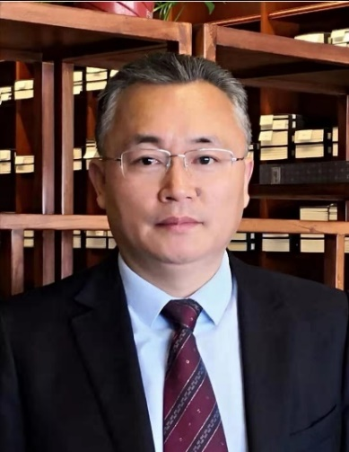
Chair of TC219 ISSMGE
Vice President of Chinese Institution for Soil Mechanics and Geotechnical Engineering
Professor, School of Civil Engineering, Tianjin University, P.R.China
Email: 18602683655@vip.163.com
Mobile: +086 18602683655
Academic Appointments
2002 – present Professor, Tianjin University, Tianjin, China
2004 – 2005 Visiting Scholar, Cambridge University, U.K
1998 – 2002 Associate Professor, Tianjin University, Tianjin, China
1995 – 1998 Lecturer, Tianjin University, Tianjin, China
Non-Academic Positions
2018-present Executive Associate Dean, Graduate School, Tianjin University
2014-2017 Dean, School of Civil Engineering, Tianjin University
2010-2014 Associate Dean, School of Civil Engineering, Tianjin University
Research Interests or Specialty Area
System performance of geotechnical structures; Deep excavation in soft ground
Underground construction in soft ground; Pile foundation; Ground Improvement
Awards, Recognition and Honors
- 2013 R.M. Quigley Award. The Canadian Geotechnical Society.
- Second Prize for National Science and Technology Progress Award. Safety control and cost-effective design of large and deep excavation. Chinese Government, 2015.
- First Prize for National Science and Technology Progress Award. Theories, key technologies and engineering applications of composite ground. Chinese Government, 2019.
- Excellent Teacher Award, Tianjin Municipal Government, China, 2004.

